**EPSA**



Large Language Models Workshop - Wednesday June 25th

Carlos III University - Madrid, Spain

# Programme organisers

Ray Duch (University of Oxford)  
Livia Schubiger (D-GESS, ETH Zurich)

# Schedule

# 

# Conference Venue Location and Directions

Universidad Carlos III de Madrid Campus Madrid- Puerta de Toledo Ronda de Toledo, 1 28005 Madrid - <https://www.google.com/maps/dir//Universidad%20Carlos%20III%20de%20Madrid%20Campus%20Madrid-%20Puerta%20de%20Toledo%20Ronda%20de%20Toledo,%201%2028005%20Madrid>

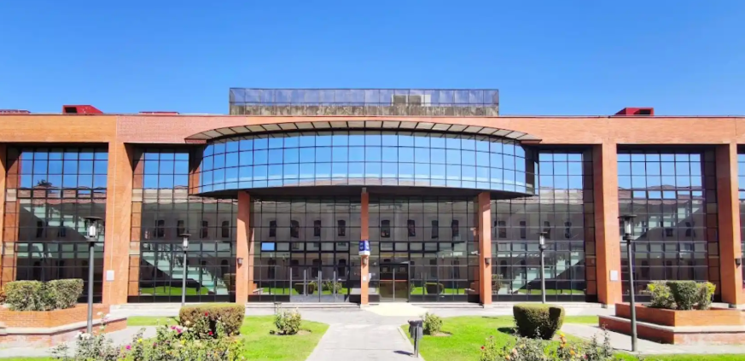

**Free Internet / Wi-Fi Information**

SSID (Network Name): TBC

Password: TBC

**Registration**

The registration desk will be in the foyer at the main university entrance   
  
Any queries, email Mel – melanie.sawers@nuffield.ox.ac.uk